Screen Design -- Tony Liebig – Individual Project – Enterprise Java, Spring 2017

Dialog For Sign In Page

Email Address

Password

Clear

Submit

Password Reset

Sign In Dialog Page

First Name

Last Name

Email Address

Password

Re-enter Password

Clear

Submit

About Page

Dilution Calculator | Inventory | Sign In | Sign Up Search

About

About text, likely gory details will go here.

Inventory Page

Update Chemical By ID #

Delete Chemical

Search Inventory

Add New Chemical

Home Page Search

New Chemical Page

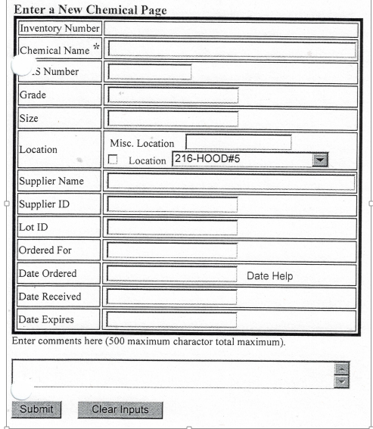

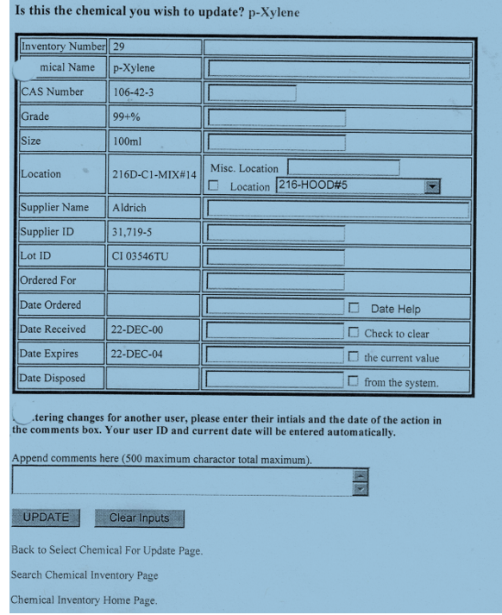

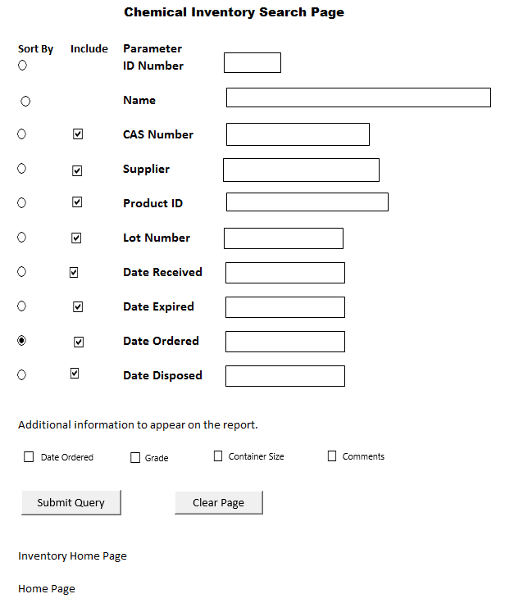

Home Page

Dilution Calculator | Inventory | Sign In | Sign Up | About Search

**Welcome the** **Chemical Inventory & Dilution Documentation System**

Blurb hyping the web site



**Stock standard creation page. This page determines the number of dilution levels.**

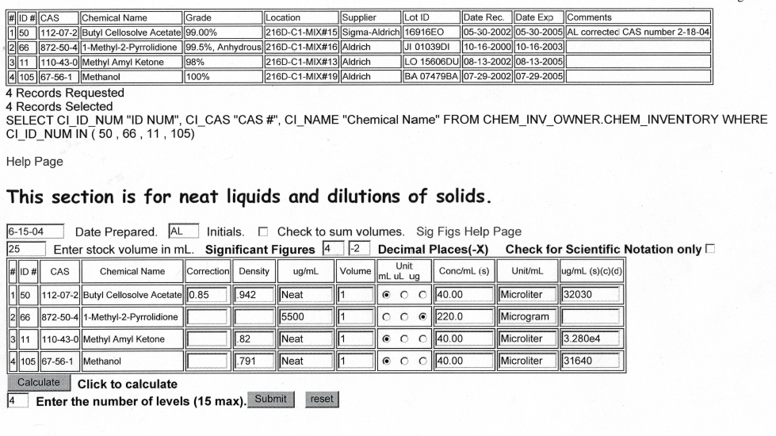

Calculation page.

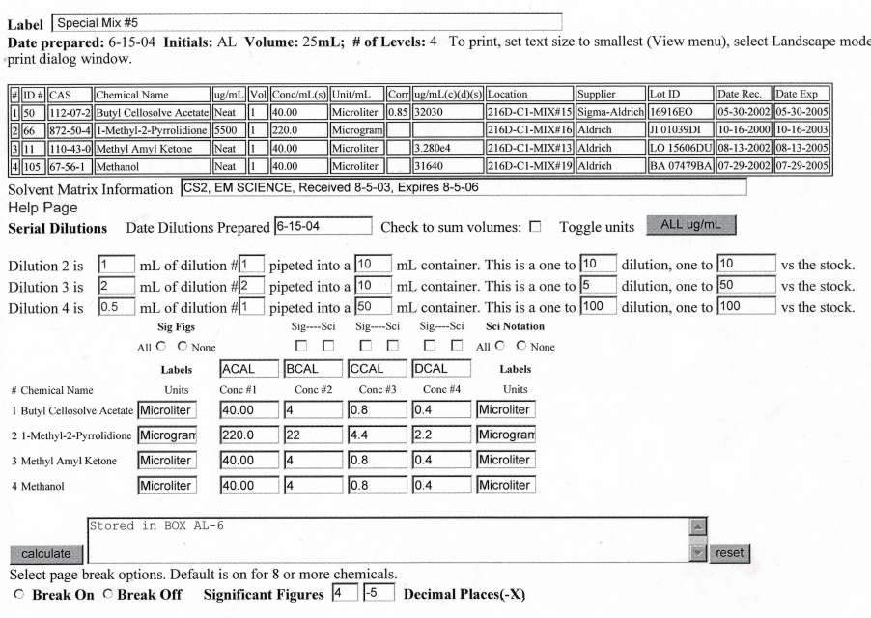

Download